Name: Shruti Gupta

Roll: 244CA051

Assignment 5:

CREATE TABLE Bank (

bk_code VARCHAR(10) PRIMARY KEY,

bk_name VARCHAR(50) NOT NULL,

bk_address VARCHAR(100)

);

CREATE TABLE Branch (

br_id VARCHAR(10) PRIMARY KEY,

br_name VARCHAR(50) NOT NULL,

br_address VARCHAR(100),

bk_code VARCHAR(10),

FOREIGN KEY (bk_code) REFERENCES Bank(bk_code)

);

CREATE TABLE Customer (

cust_ID INT PRIMARY KEY,

cust_name VARCHAR(50) NOT NULL,

phone_no VARCHAR(15) UNIQUE,

address VARCHAR(100)

);

CREATE TABLE Account (

acc_no INT PRIMARY KEY,

acc_type VARCHAR(20) CHECK (acc_type IN ('savings', 'current')),

balance DECIMAL(10,2),

br_id VARCHAR(10),

FOREIGN KEY (br_id) REFERENCES Branch(br_id) ON DELETE CASCADE

);

CREATE TABLE Customer_Account (

cust_ID INT,

acc_no INT,

PRIMARY KEY (cust_ID, acc_no),

FOREIGN KEY (cust_ID) REFERENCES Customer(cust_ID) ON DELETE CASCADE,

FOREIGN KEY (acc_no) REFERENCES Account(acc_no) ON DELETE CASCADE

);

CREATE TABLE Loan (

loan_ID INT PRIMARY KEY,

loan_type VARCHAR(50),

amount DECIMAL(10,2),

br_id VARCHAR(10),

FOREIGN KEY (br_id) REFERENCES Branch(br_id) ON DELETE CASCADE

);

CREATE TABLE Customer_Loan (

cust_ID INT,

loan_ID INT,

PRIMARY KEY (cust_ID, loan_ID),

FOREIGN KEY (cust_ID) REFERENCES Customer(cust_ID) ON DELETE CASCADE,

FOREIGN KEY (loan_ID) REFERENCES Loan(loan_ID) ON DELETE CASCADE

);

2. Insert at least five records in each table

INSERT INTO Bank VALUES

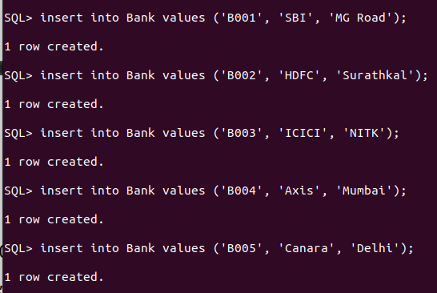

INSERT INTO Branch VALUES

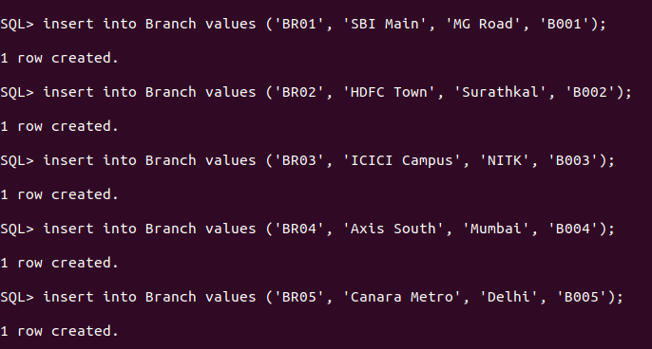

INSERT INTO Customer

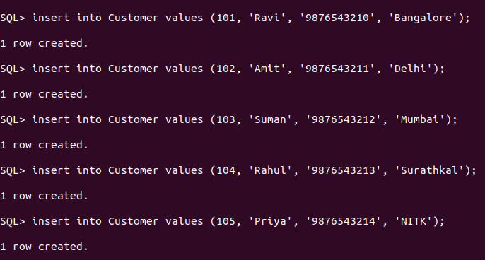

INSERT INTO Account VALUES

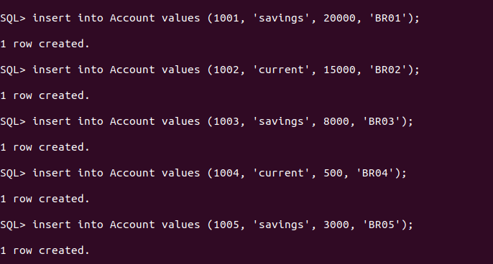

INSERT INTO Customer_Account VALUES

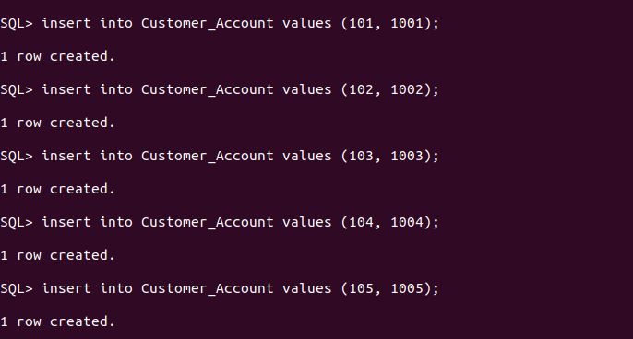

INSERT INTO Loan VALUES

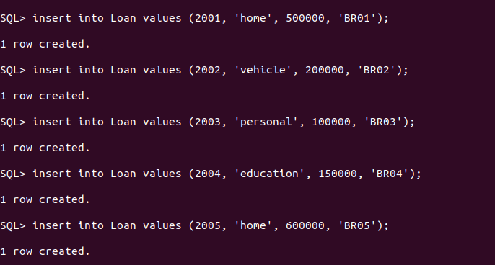

INSERT INTO Customer_Loan VALUES

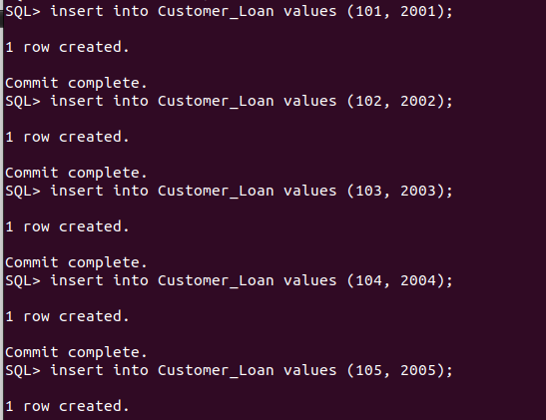

3.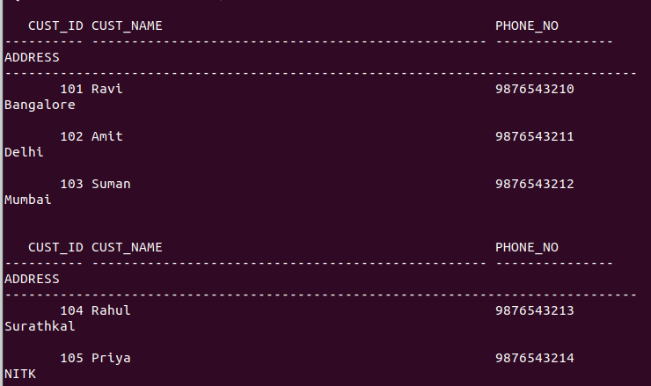 List the details of all customers.

4.Find the cust_ID and phone number of customer ‘Ravi’

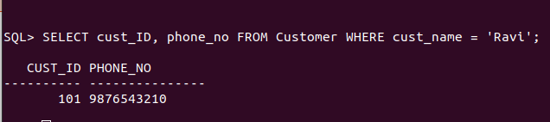

5. Find the Address of all branches of br_01

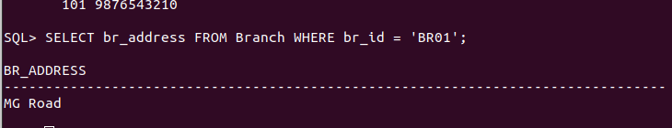

6. Find the details of Customer having ID 103

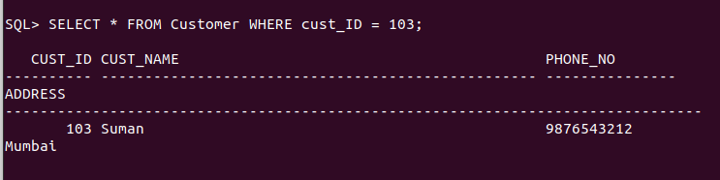

7. List the account details having balance more than 10000

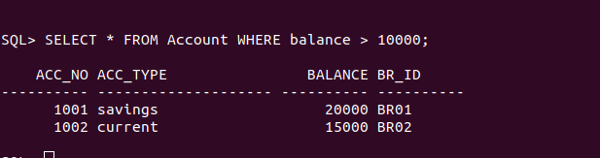

8. List the account details of branch br_02

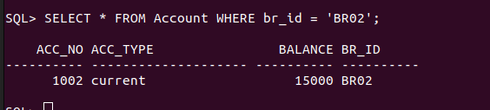

9. List the loan details of branch br_01

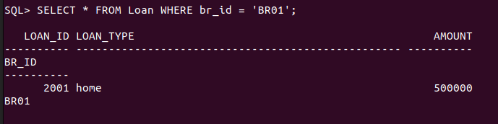

10. List the account details with their branch address

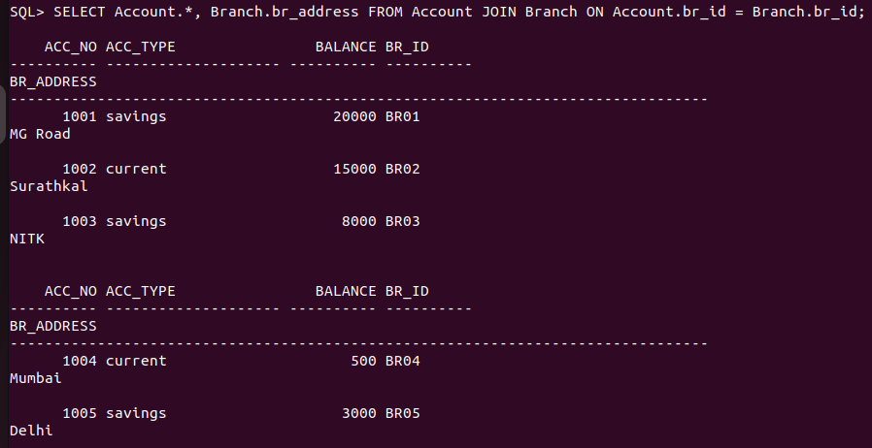

11. List the customer details with their account details

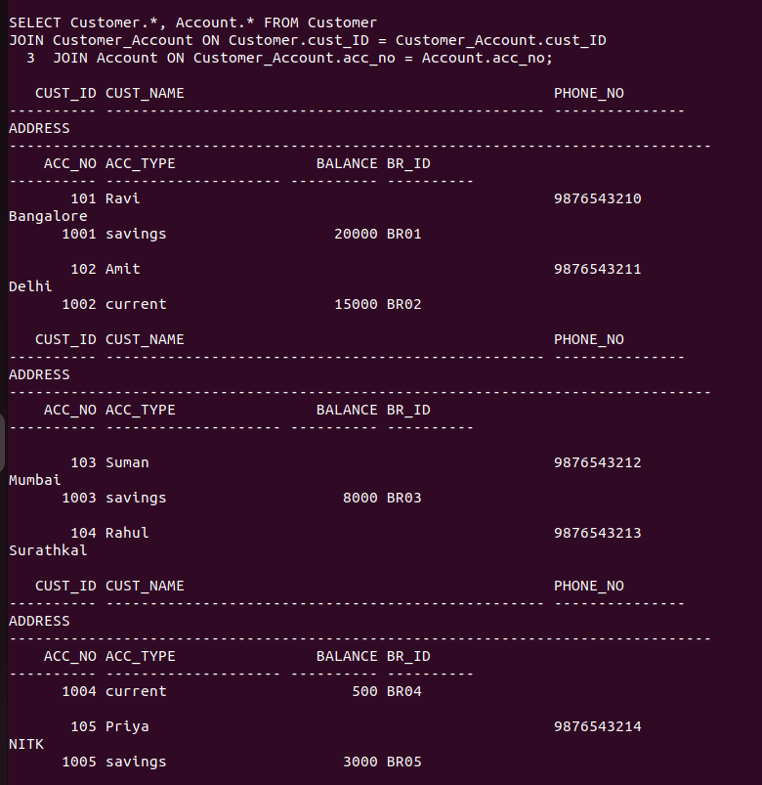SELECT Customer.* FROM Customer

JOIN Customer_Account ON Customer.cust_ID = Customer_Account.cust_ID

JOIN Account ON Customer_Account.acc_no = Account.acc_no

JOIN Branch ON Account.br_id = Branch.br_id

WHERE br_name = 'Surathkal';

12. List the customer details having account type ‘savings’

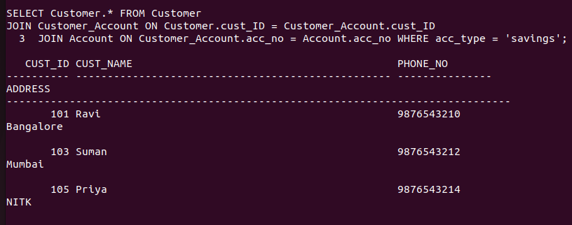

13. List the customer details having vehicle loan

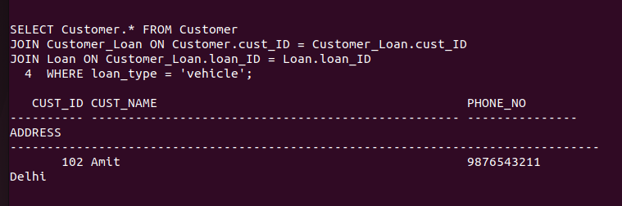

14. List the branch names of all accounts

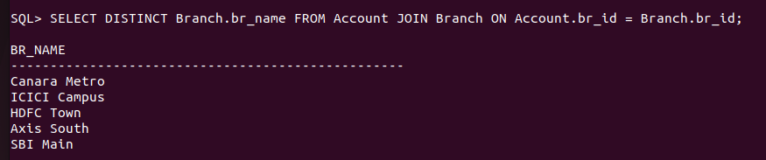

15. List the customer details going to ‘Surathkal’ branch

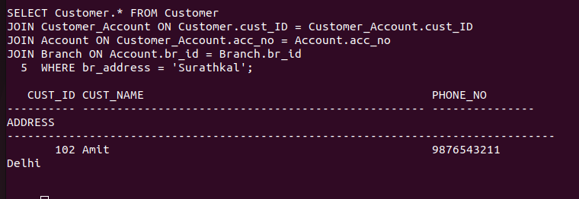

16. List the customers having loan account in ‘MG Road’ branch

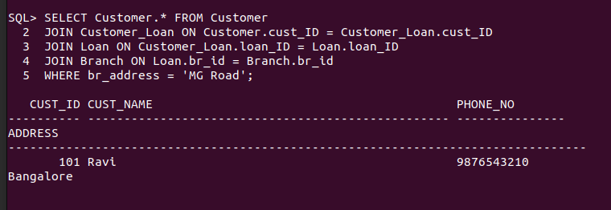

17. Find the customers having balance between 1000 to 10000

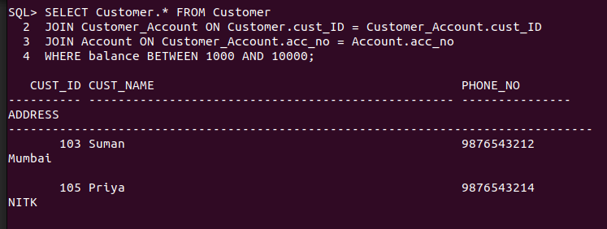

18. Give a bonus of rupees 100 to customers having more than 10000 balance

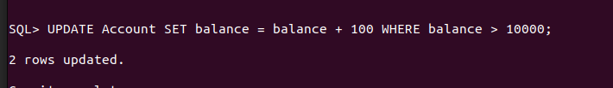

19. Deduct 50 rupees from customers having less than 500 balance



20. Give the customer details having home loan

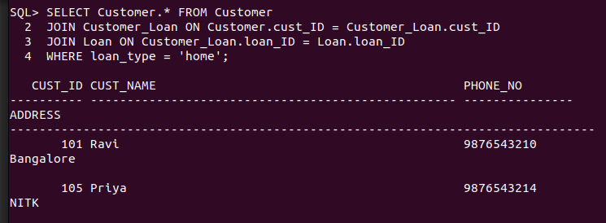

21. Give the customer details having home loan in ‘NITK’ branch

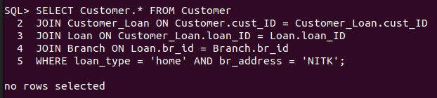

22. Add a column NOMINEE to the customer table



23. List all the account numbers in ascending order of their balance

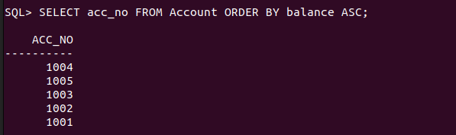

24. Count the number of customers having account type savings

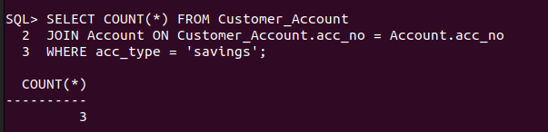

25. Count the number of customers for each account type

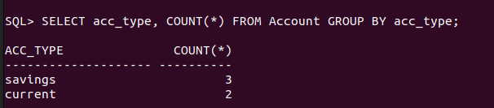

26. Find the total balance in Savings account

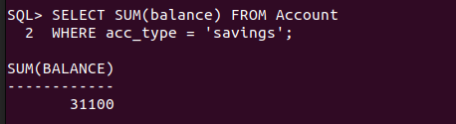

27. Find the average balance of Current account

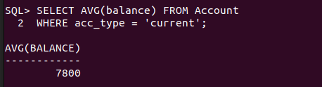

28. Find the average balance for each account type

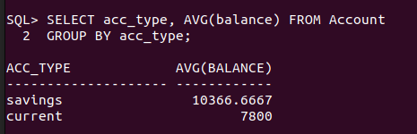

29. Find the customer details having maximum balance

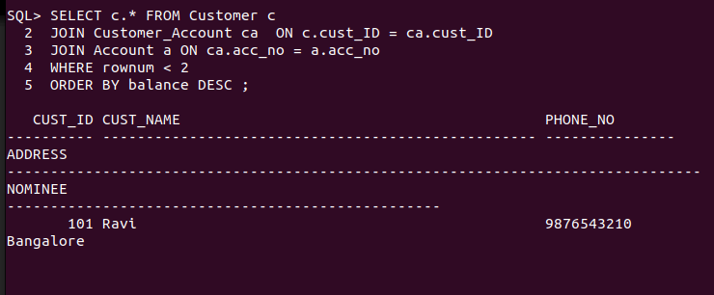

30. Find the average amount for vehicle loan



31. Find the average balance in each branch

